Unlocking Cognitive Health Insights

Javier Corpus
May 30, 2025

Unlocking Cognitive Health Insights
A cognitive score is a numerical representation of an individual's cognitive abilities, which include functions like memory, attention, reasoning, problem-solving, language comprehension, and decision-making. These scores are derived from standardized tests designed to assess different aspects of cognition and are used in clinical, educational, and research settings.
With enough information, we can derive insights that benefit different types of industries, including healthcare, corporate wellness, and education.

Why is Cognitive Score important?
A cognitive score is important because it provides a way to measure an individual's cognitive abilities, such as memory, reasoning, problem-solving, and attention. This score can help identify strengths and weaknesses in cognitive functioning, as well as track changes over time in response to treatment or aging.
A cognitive assessment can help us with different items, such as:
- Diagnosis of Cognitive Impairment – Helps identify conditions like dementia, Alzheimer’s disease, traumatic brain injury (TBI), or learning disabilities.
- Monitoring Cognitive Decline or Improvement – Tracks changes over time in aging individuals or patients undergoing treatment.
- Educational and Workplace Assessments – Determines learning disabilities, giftedness, or job-related cognitive demands.
- Research and Clinical Trials – Used to measure the effectiveness of interventions (e.g., medications, therapies).
- Mental Health Evaluations – Assesses cognitive effects of depression, schizophrenia, or ADHD.

Why should we invest in a Cognitive Score predictive model?
Currently, understanding and proactively addressing cognitive strengths and challenges within our organization is a reactive process. This leads to missed opportunities and suboptimal performance, delayed interventions, reduced satisfaction among employees and ultimately, higher costs. We lack a scalable, data-driven system that would allow us to gain timely and actionable insights.
A cognitive score predicting model is not about measuring an abstract score; it’s about leveraging relevant data to create personalized profiles of cognitive functions, allowing us to anticipate needs and have more optimal interventions. By analyzing existing datasets, we can build a model that will help us make more informed decisions. This model will be developed and validated against established cognitive assessments to ensure accuracy and trustworthiness.
This model could help us have a strategic advantage in employees’ development, giving us a competitive edge. It will also help us create personalized development plans and learning paths, moving from “gut feeling” to data-driven decisions for critical and operational talent. The model will be designed with HIPAA and our internal policy compliance from day one, adherence to the highest security standards and access controls.
This cognitive score model can be created in different phases:
- Phase 1: Discovery & Data Audit - We can identify all relevant data sources and assess data quality.
- Phase 2: Model development and validation – We will build and train the model using historical data, validating it against known benchmarks.
- Phase 3: Integration & Deployment – The model’s insight can be integrated into our existing platforms, rolling it out to a broader audience.
- Phase 4: Continuous Improvement – We will establish an ongoing monitoring and refinement of the model.
We propose establishing a core project team, identifying key data owners, and scheduling a detailed technical deep-dive within the next two weeks to finalize the detailed project plan and budget.

Dataset used to train and test the initial model
The models used in this exercise were trained and tested using a dataset obtained from Kaggle (https://www.kaggle.com/datasets/samxsam/human-cognitive-performance-analysis) on April 2, 2025. It consists of the following fields:
Field | Description
User_ID | A unique identifier assigned to each user in the dataset.
Age | The age of the individual, represented as a numerical value.
Gender | The gender of the individual (Male, Female, or Other).
Sleep_Duration | The average number of hours the individual sleeps per night.
Stress_Level | The self-reported stress level on a scale from 1 to 10, where 1 indicates no stress and 10 indicates extreme stress.
Diet_Type | The dietary preference of the individual, categorized as Vegetarian, Non-Vegetarian, or Vegan.
Daily_Screen_Time | The average number of hours spent on digital screens (e.g., phone, computer, TV) per day.
Exercise_Frequency | The frequency of physical exercise, categorized as Low, Medium, or High.
Caffeine_Intake | The amount of caffeine consumed daily, measured in milligrams (mg).
Reaction_Time | The individual’s reaction time in milliseconds (ms), measured through cognitive tests.
Memory_Test_Score | Score from 0 to 100.
Cognitive_Score | Score from 0 to 100.
AI_Predicted_Score | Score from 0 to 100.

Exploratory Data Analysis
Histogram – Cognitive Score Distribution, staked by Memory Score Group.
This histogram shows the distribution of the cognitive score, stacked by Memory Score Group (low, medium or high). Not unexpectedly, in the lowest cognitive scores we have mostly low memory scores as well. What is surprising is finding high memory scores with a low cognitive score, and vice versa. We can see some results with low memory score, but a cognitive score of 100.

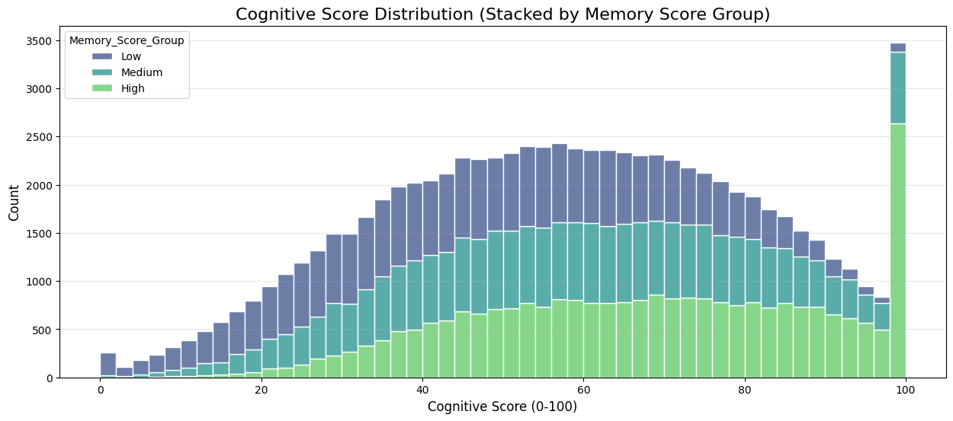

Box Plot – Cognitive Score by Diet Type.
This visualization shows that the average cognitive score (around 60) is the same for all three diet types, however the vegan's lowest score is higher than the other two diet types. Overall, vegans had higher scores. Non-Vegetarians is the only group that scores from 0 to 100.

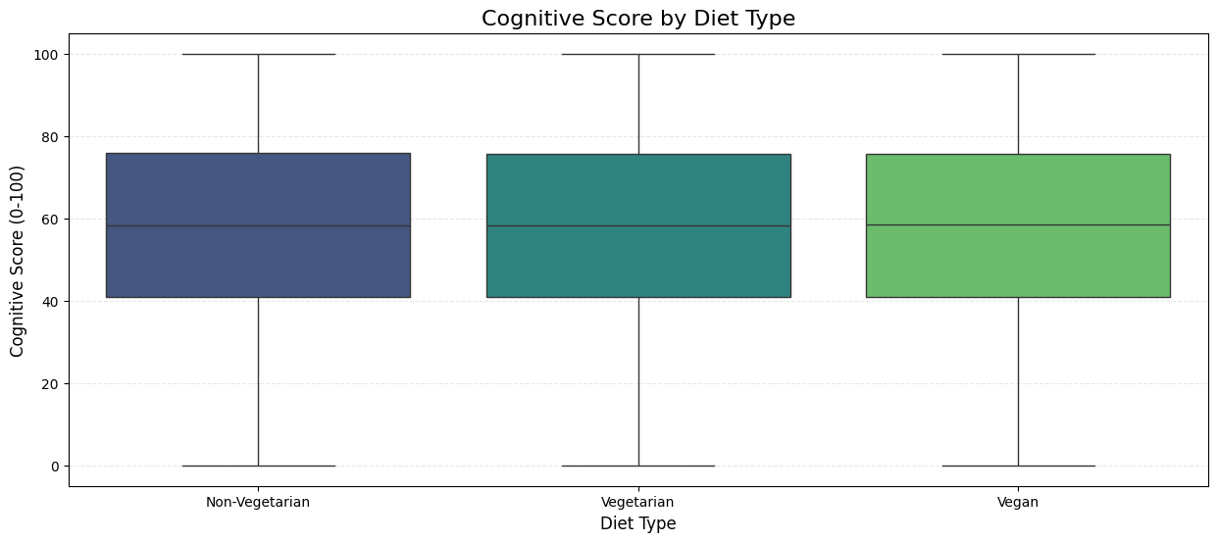

Scatter plot – Sleep Duration vs Cognitive Score.
This visualization shows that there is no significant correlation between sleep duration and cognitive score. There are individuals with few hours of sleep per night and still had a high score, and there are also individuals with 10 hours of sleep per night and a low score. According to this data, sleep duration is not a factor that affects the cognitive score.

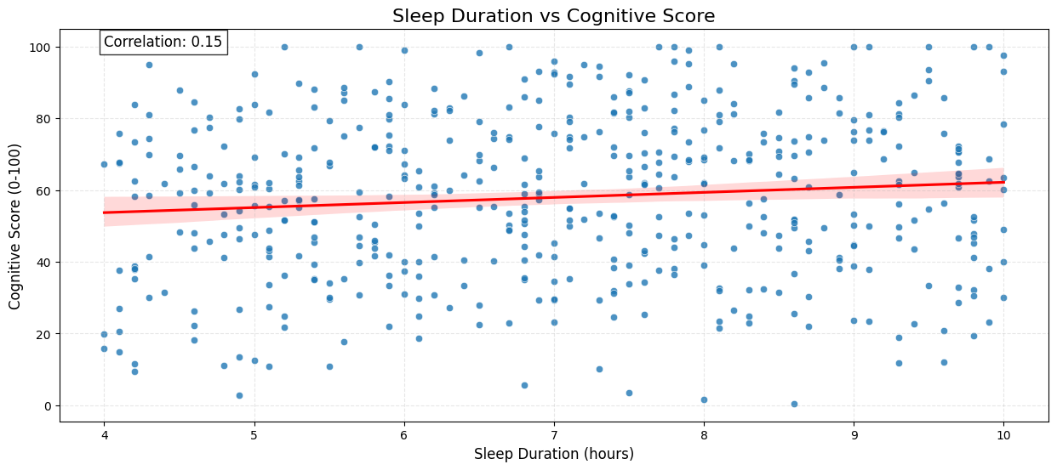

Data Preparation.
A Linear Regression model was chosen as baseline for this project. This type of model requires data to meet certain conditions that the original dataset didn’t have. Because of this, and to improve the performance of the model, the following transformations were done:
- Dropped features that are not relevant for this exercise (User_ID).
- Checked for missing values (no missing values were found in the original dataset).
- Created new features: Screen Time to Sleep Duration Ratio, and Age Bins.
- Detected outliers that could skew the model.
- Created dummy variables from the three categorical variables in the dataset.
- Scaled the numerical features.
- After creating dummy variables, some features became unnecessary (Exercise_Frequency, Age_Group). These were removed.
- Converted “TRUE” and “FALSE” string values into numerical ones (TRUE = 1, FALSE = 0).
- Dropped feature “AI_Predicted_Score”, as this is likely the result of a different model.

Model Building and Evaluation – Linear Regression Model
A Linear Regression model was chosen because the target feature (Cognitive_Score) is a numerical variable, which aligns with the output of this model. It also provides coefficients for each feature, making it easier to understand how each predictor influences the target feature.
The following metrics were used to evaluate this model:
- Mean Squared Error (MSE): It measures the average squared difference between the predicted and actual values.
- Root Mean Squared Error (RMSE): This is the square root of MSE, it measures the average magnitude of prediction errors in regression models.
- Mean Absolute Error: It's the average absolute difference between predicted and actual values.
- R-squared: It measures the proportion of variance in the target explained by the model. The values go from 0 to 1, where 1 means a perfect fit.

Results of the Linear Regression model:
Metric | Linear Regression
Mean Squared Error (MSE) | 3.74
Root Mean Squared Error (RMSE) | 1.94
Mean Absolute Error (MAE) | 1.31
R-squared | 0.99

Scatter Plot – Actual vs Predicted Cognitive Scores:
The following plot shows a comparison between the actual cognitive scores vs the predicted ones. Linear Regression seems to be a great fit for this dataset.
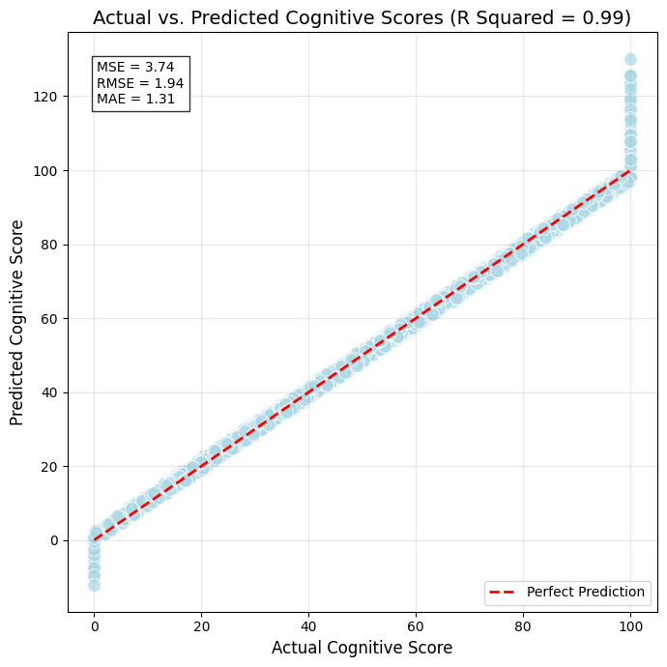

Model Building and Evaluation – Random Forest Regressor
This second model was chosen due to its ability to handle the type of data from the original dataset and deliver a high predictive accuracy. A Random Forest Regressor model can work with numerical and categorical features without any extensive preprocessing. This model can also capture non-linear relationships. Cognitive Score is likely influenced by various factors, and unlike a Linear Regression Model, a Random Forest automatically models non-linear patterns.
We used the same metrics as with the Linear Regression model, for a direct, one-to-one comparison. These were the results:
Metric | Random Forest | Linear Regression
Mean Squared Error (MSE) | 17.75 | 3.74
Root Mean Squared Error (RMSE) | 4.21 | 1.94
Mean Absolute Error (MAE) | 3.37 | 1.31
R-squared | 0.97 | 0.99

Scatter Plot – Actual vs Predicted Cognitive Scores:
The following plot shows a comparison between the actual cognitive scores vs the predicted ones. Random Forest is also a great fit for this dataset.
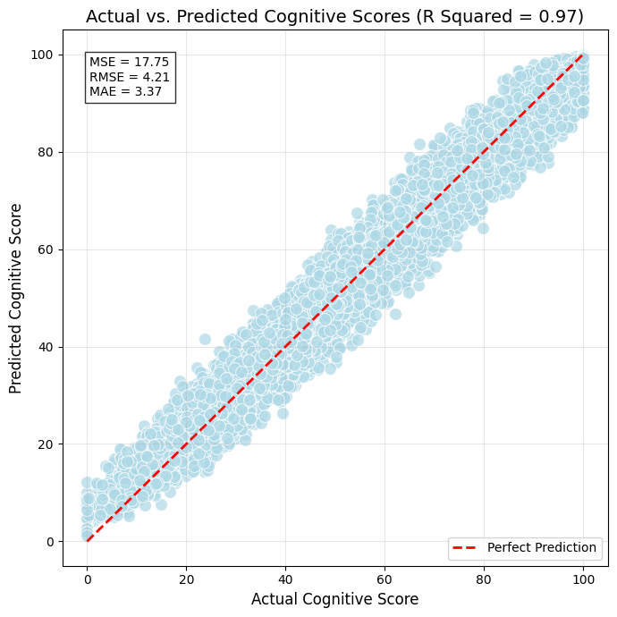

Conclusion
The Linear Regression model performed better, but it requires heavier preprocessing of data. The Random Forest model had lower metrics, but it doesn’t require a lot of preprocessing.
Here is a comparison of each metric:
Metric | Random Forest | Linear Regression | Best Performer
Mean Squared Error (MSE) | 17.75 | 3.74 | Linear Regression
Root Mean Squared Error (RMSE) | 4.21 | 1.94 | Linear Regression
Mean Absolute Error (MAE) | 3.37 | 1.31 | Linear Regression
R-squared | 0.97 | 0.99 | Linear Regression

The Linear Regression model outperforms Random Forest across all metrics. This is mainly due to all the preprocessing done to the dataset. It appears that the relationship between Cognitive Score and all features is linear, which explains why this model is a better choice than Random Forest.
It might be possible to improve the accuracy of the Random Forest model by adjusting hyperparameters, like max_depth (to reduce overfitting), or n_estimators.

Recommendations
The Linear Regression model is ready to be deployed, given its great metrics. All the metrics (MSE, RMSE, MAE) align, suggesting this model is robust. New data needs to be preprocessed before using it, but that will help getting better predictions of the Cognitive Score. We need to use this model with a bigger dataset, to make sure the metrics are consistent with the dataset used for training.

Potential Challenges
We need to validate the model on a holdout dataset or via cross-validation, to ensure that the high R-squared score (0.99) is not due to overfitting. If the performance drops significantly on new data, we might need to simplify the model by removing features with low impact (like Gender).
We need to make sure the model does not inadvertently reinforce biases. E.g., if Exercise_Frequency is biased towards certain demographics, we need to address the data collection gaps.
If non-linear relationships are needed and we can invest more time doing feature engineering and hyperparameter tunning, a Random Forest model can be re-evaluated.

